One of your Year 4 suggested reads  TITLE: ___________________________  AUTHOR: _______________________  Finished: ___________Rating: _____ | A NON-FICTION BOOK ABOUT AFRICA  TITLE: ___________________________  AUTHOR: _______________________  Finished: ___________Rating: _____
A book written by Michael Morpurgo  TITLE: ___________________________  AUTHOR: _______________________  Finished: ___________Rating: _____ | A POEM ABOUT A BEACH OR RIVER  TITLE: ___________________________  AUTHOR: _______________________  Finished: ___________Rating: _____
A BOOK ABOUT SURVIVAL IN AN ENVIRONMENT  TITLE: ___________________________  AUTHOR: _______________________  Finished: ___________Rating: _____ | A book recommended to you by a friend  TITLE: ___________________________  AUTHOR: _______________________  Finished: ___________Rating: _____
Your own choice from any genre  TITLE: ___________________________  AUTHOR: _______________________  Finished: ___________Rating: _____ | A GRAPHIC NOVEL OR COMIC OF YOUR CHOICE  TITLE: ___________________________  AUTHOR: _______________________  Finished: ___________Rating: _____
BOOKS I HAVE READ THIS TERM Autumn 2021
https://ecofriendlykids.co.uk/how-electricity-made-easy-explanation/

AUTHOR: _______________________
Finished: ___________Rating: _____
A NON-FICTION BOOK ABOUT RECYCLING

TITLE: ___________________________
AUTHOR: _______________________
Finished: ___________Rating: _____
AN INTERESTING NEWSPAPER OR MAGAZINE ARTICLE

TITLE: ___________________________
AUTHOR: _______________________
Finished: ___________Rating: _____
A BOOK ABOUT THE ROMANS in readiness for revisiting your learning from last year

TITLE: ___________________________
AUTHOR: _______________________
Finished: ___________Rating: _____

Remember to read each text thoroughly… your teacher may ask you questions about what you have read!
- Give each text a rating out of 5 e.g. 4/5

- Record the date you finished the text

- Get your grown up to sign your passport once you’ve completed the task
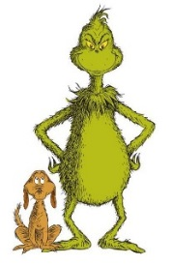
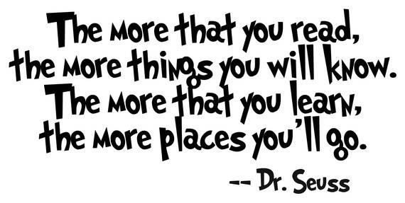

YEAR 4 READING PASSPORT
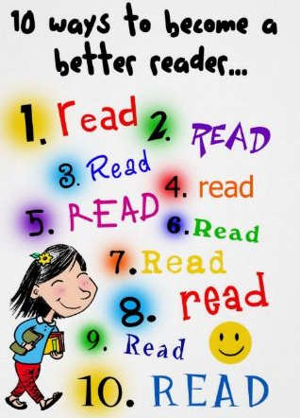
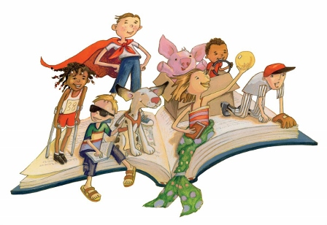

NAME:_____________________________
Help your child to complete their reading passport to be in for a chance to win a prize!
Good readers, make good writers… It’s a fact!
Open up your mind to a range of different books this term.

