Year 3 Homework Grid
Please choose a piece of homework from this grid each week this half term, you may complete more than one a week if you wish! I look forward to receiving your fantastic home learning and lovely ideas! You can submit photos and videos via email (year3@englishmartyrs.school) or bring your work into school!
Practice your 2, 5 and 10 times tables.  Practice counting in 2s, 5s and 10s first if you need to.  Make sure you can recall these times tables out of order up to 12X.  Record on Times Tables Rockstars. | English:  Write a diary entry about something interesting you did over the summer holidays.  Remember your punctuation and use of adventurous vocabulary to describe what it was like and how you felt. | In art, we will be using warm and cool colours to represent feelings.  Can you create a colourful picture based on the book you are reading using either warm or cool colours to show a particular feeling of a character.
Science:  Can you create a skeleton and label the bones, either using the common bones names or the scientific names. You can be as creative as you like when representing the skeleton. | 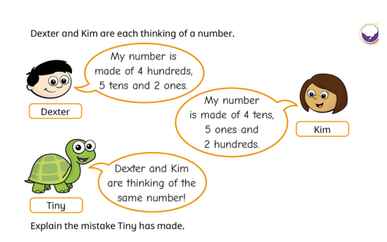 | 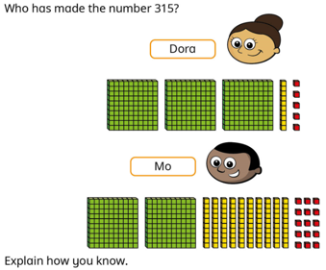
In geography, we are exploring coastal areas and the benefits they bring us. We are also thinking about how we affect the coast. Watch this video and complete the activities to expand your knowledge of the coast:  What did you find most interesting? Can you produce a poster or leaflet to show the interesting facts you have learned? | In computing, we are developing our understanding of digital devices. Using the painting tool (https://kleki.com/), create a piece of artwork. Then create the same piece without your digital tools.  Discuss these questions:  - Which method did you prefer?  - Which bits did you find easier or harder in each activity?  - How did you fix mistakes in each activity?  - Do you need to be good at using a computing to produce good art? | In RE, we are thinking about how God’s love can fill our homes and how His love teaches us to show love in our family.  Do something with the people that you love. How does it make you feel? Write, draw, paint, dance or sing about it! Express that feeling in a way that’s best for you.

